|  |  |
| --- | --- |
| **Name :-** | Aryan Dilipbhai Langhanoja |
| **Enroll No: -** | 92200133030 |

## Water level control using basic AND & NOT gates

* **Aim** :-

The aim of the experiment is to use the combination of AND & NOT gates in water level controller application. The user will be able to find the output status of the electronic lock for given combination of inputs. The user will be able to analyze, construct and simulate to verify any combinational logic circuit for a given problem statement using the generalized simulator.

* 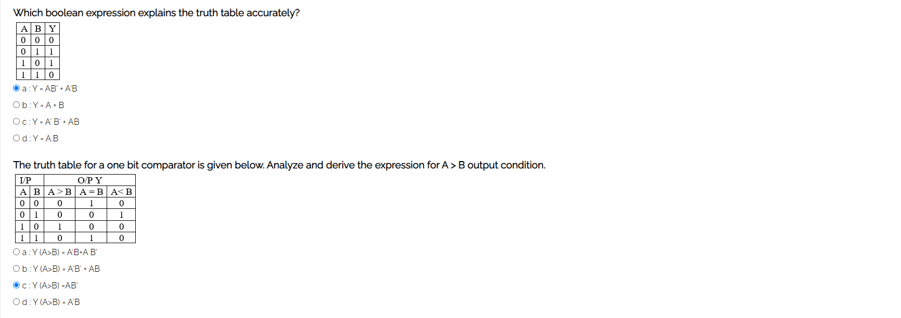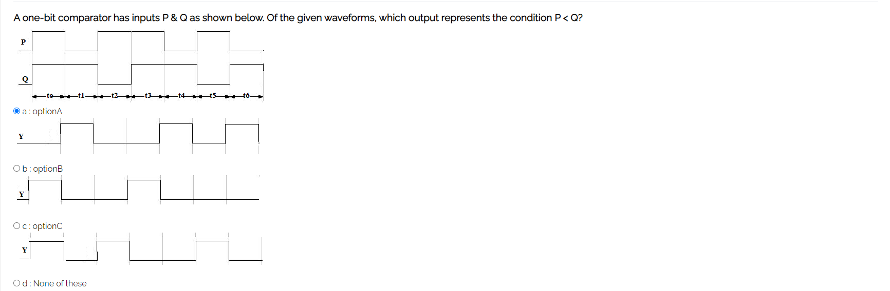**Pre-test :-**

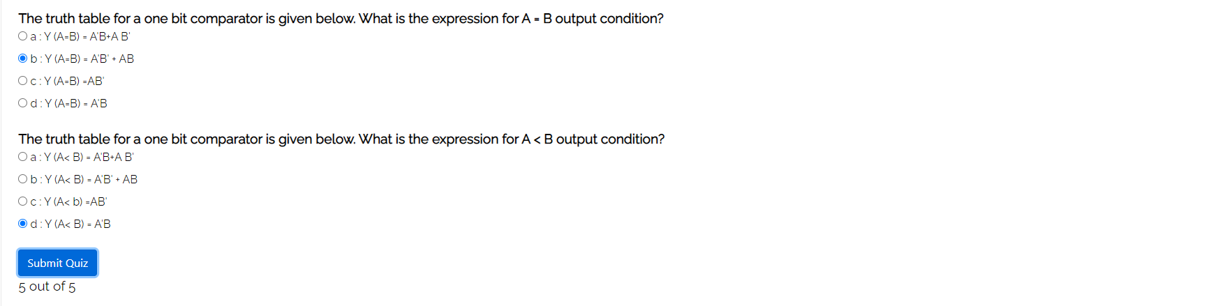

* **Simulation :-**

**T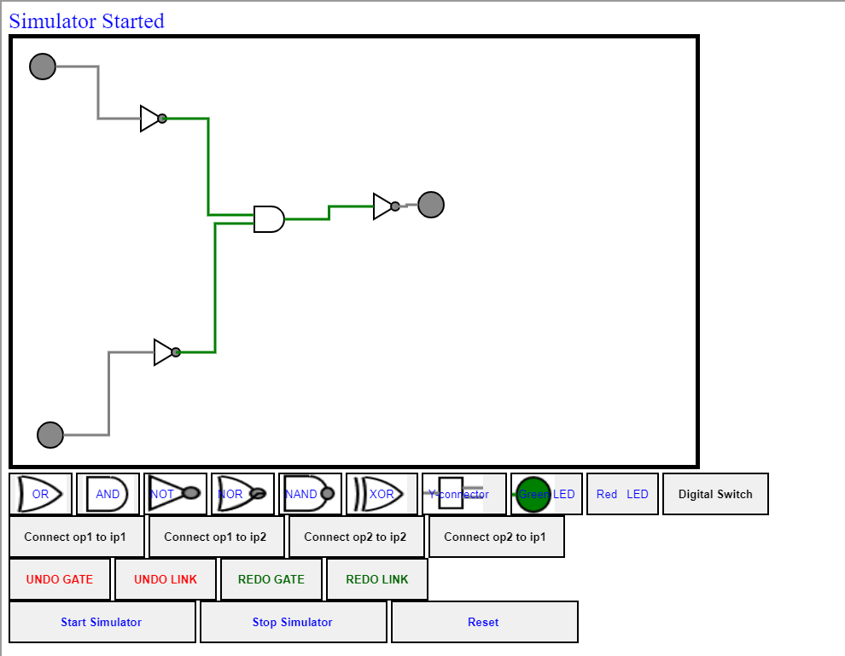ask:-** Construct and verify an OR gate using AND & NOT gates.

* **Post-test :-**

